

"Limb Revive Website"

A Project Report

By:

Amal Faleh Al-Anazi

Shouq SalemAl-Atwi.

Anwar Suleiman Al-Balawi

Hanin Ajloub Al-Otaibi

Amal Halaf Al-Madhi

Supervised by

Dr.Lubna Al-Harbi

Department of Information Technology

Faculty of computer and information technology.

University of Tabuk.

December 2023

Declaration

I hereby declare that this project report is based on my original work except for

citations and quotations which have been duly acknowledged. I also declare that it has not been previously and concurrently submitted for any other degree or award at

University of Tabuk or other institutions.

|  |  |
| --- | --- |
| ID | Name |
| 421002909 | Amal Faleh Al-Anazi |
| 421002493 | Shouq Salem Al-Atwi |
| 421000937 | Anwar Suleiman Al-Balawi |
| 421004411 | Hanin Ajloub Al-Otaibi |
| 421004985 | Amal Halaf Al-Madhi |

Abstract

Prosthetic limbs are artificial organs that are used as a replacement for missing organs such as hands and legs, as they remove the obstacles and difficulties that those who are missing organs may face,and help perform appropriate activities and functions. They also provide the person with the ability to move from one place to another, which provides a greater sense of independence and improves the psychological state. The goal of this site is to help people who are missing limbs, provide them with them, contribute to motivating individuals, facilitate donation through the services available on the site, and deliver them to the largest group of people who would like to donate. The site is characterized by a simple and easy, uncomplicated interface and useful services such as the presence of a booth for gatherings and conferences concerned with prosthetic limbs, and the presence of a discussion board to express opinions and benefit from experiences as well .

List of Contents

|  |  |
| --- | --- |
| Contents | Page |
| 1. Introduction | |
| 1.1 Background | 7 |
| 1.2 Problem Overview | 7 |
| 1.3 Aims and Objectives | 8 |
| 1.4 Report’s Layout | 8 |
| 2. Background and Related Works | |
| 2.1 Introduction | 9 |
| 2.2 Explanation of the System | 9 |
| 2.3 Related Works | 10 |
| 3. Methodology | |
| 3.1 Introduction | 13 |
| 3.2 Functional and Non-Functional Requirements | 13 |
| 3.3 Use Case | 14 |
| 3.4 Activity Diagram | 18 |
| 3.5 Sequence Diagram | 22 |
| 3.6 ER Diagram | 23 |
| 3.7 Class Diagram | 24 |
| 4. Implementation | |
| 4.1 Introduction | 25 |
| 4.2 Program Requirement | 25 |
| 4.3 Output Layout | 26 |
| 5. Conclusion and Recommendations | |
| 5.1 Conclusion | 35 |
| 5.2 Recommendations | 35 |
| 5.3 Resources and References | 36 |

List of Tables

|  |  |
| --- | --- |
| Table | Page |
| Table 2.1 Related Works | 12 |
| Table 3.1 Functional and Non-Functional Requirements | 13 |

List of Figures

|  |  |
| --- | --- |
| Figure | Page |
| Figure 2.1 Prosthetic Devices | 10 |
| Figure 2.2 Artificial Limbs King Salman Center | 11 |
| Figure 3.1 Admin Use Case | 14 |
| Figure 3.2 Hospital Admin Use Case | 15 |
| Figure 3.3 User Use Case | 16 |
| Figure 3.4 Donator Use Case | 17 |
| Figure 3.5 Admin Activity Diagram | 18 |
| Figure 3.6 Hospital Activity Diagram | 19 |
| Figure 3.7 User Activity Diagram | 20 |
| Figure 3.8 Donator Activity Diagram | 21 |
| Figure 3.9 Sequence Diagram | 22 |
| Figure 3.10 ER Diagram | 23 |
| Figure 3.11 Class Diagram | 24 |
| Figure 4.1 Log in | 26 |
| Figure 4.2 Sign up | 26 |
| Figure 4.3 Home page | 27 |
| Figure 4.4 Installation | 27 |
| Figure 4.5 Installation | 28 |
| Figure 4.6 Installation | 28 |
| Figure 4.7 Installation | 29 |
| Figure 4.8 Donation | 29 |
| Figure 4.9 Donation | 30 |
| Figure 4.10 Physical Therapy | 30 |
| Figure 4.11 Physical Therapy | 31 |
| Figure 4.12 Physical Therapy | 31 |
| Figure 4.13 Feedback | 32 |
| Figure 4.14 Conferences | 32 |
| Figure 4.15 Profile | 33 |
| Figure 4.16 Notifications | 33 |
| Figure 4.17 Chat Support | 34 |
| Figure 4.18 Discussion Board | 34 |

**1. Introduction**

1.1 Project Background

Amputation is a permanent distortion. For some, relieving pain or illness in the affected limb may be the appropriate solution for it is prostheses, for those who lose a healthy limb, resentment is understandable. Despite modern prostheses, some adaptation is needed, and people differ in their ability to adapt to the change in body image, and sometimes lifestyle is a permanent thing

As for the costs of prostheses, they are expensive, but modern industrial manufacturing, especially with injection molded plastic, can create lightweight and low-cost components with enough function for limited walking, and this may be quite enough for elderly limb loss.

1.2 Problem Overview

People who are missing limbs face many difficulties and challenges in their lives. Loss of limbs can lead to great difficulties in mobility and movement. Relying on wheelchairs or other assistive devices can be complicated in some places and circumstances. People with limb loss may also face discrimination and challenges in accessing employment opportunities, education, and health services. Loss of limbs leads to psychological and emotional problems, including depression and loss of self-confidence. People with loss of limbs The limbs need constant health care and appropriate medical care. Access to this care may be a challenge in some communities. To overcome these problems and alleviate the suffering of people with missing limbs, appropriate support and services must be provided, Including health care, treatment and rehabilitation, enhancing awareness of their rights and encouraging community solidarity, and all of these needs are provided by our “Limb Revive” website.

1.3 Aims and Objectives

The goal of the site is to serve people who use or need prosthetic limbs, facilitate the search for hospitals that provide these services, provide support and information to achieve an improvement in their quality of life, and help them adapt and make the most of these technologies.

Objectives

1- To provide information about the latest technologies: The site can provide information about recent technologies and innovations in the field of prosthetics, including developments in sensing and control technology

2- To provide a platform for social engagement: The site can be a platform for social engagement and online communities where people who have benefited from prosthetics can share experiences, stories and advice.

3-To provide resources: The site can provide useful resources such as guides on exercises and care for prosthetics, and how to maintain and maintain them.

4- To save time and effort.

1.4 Report Layout

In the first chapter, which is the introduction, we explain the problem that motivated us

to create the site and the goals of the site.

The second chapter presents studies, sites, and applications similar to our site, and explains some of the features that the site offers

In the third chapter, we studied and evaluated the differences between our site and other sites. We also added all the diagrams.

In the fourth chapter, we mentioned the program requirements, and presented the design of the interfaces using website design programs.

In the fifth and final chapter, we made a conclusion and summary of the entire project and important recommendations for Project 2.

**2. Background and Related Words**

2.1 Introduction

In this chapter, we will study and evaluate the differences between the application we are using and

other applications that currently exist with the same concept, explain the similarities and differences,

and explain the system.

2.2 Explanation of The System

The application aims to help people who have lost limbs for any reason. First, the user can open an account on the site and provide all personal and health information so that the hospital can easily communicate with him and know his condition.

-the name

-the age

-Sex

-Nationality

-Email

-the number

-Cause of loss of limb

-Does he suffer from diseases or any allergies?

After that, it will move from the registration page to the services page provided by

the site and from there

- Request to install an artificial limb. The user who wishes to have an artificial limb fitted, whether for the first time or who has previously obtained one, must submit a request to the hospital, mentioning his information, after which the user will be

contacted by the hospital until an appointment is made to determine the measurements and procedures.

- Request to remanufacture the prosthetic limb. This service is provided to users who have a prosthetic limb, but their limb has had a problem, whether it is a scratch, a break, or other problems that affect prosthetic limbs. Then a request will be submitted to the hospital with the desire to repair the limb.

- Donating a prosthetic limb A user who owns a surplus prosthetic limb may wish to donate it to other people who wish to obtain an artificial limb. This service contributes to reducing the costs for the person and also reducing effort and time.

- Physiotherapy request service. This feature contributes to submitting a request for physical therapy for people who have received their prosthetic limb for the first time, because at the beginning they face difficulty in moving and not adapting to the limb, so physical therapy makes things easier for them.

2.3 Related Works

Prosthetic Devices



Figure 2.1 Prosthetic Devices

Description:

An electronic service provided by the General Organization for Social Insurance, which enables the risk registration employee to insert prosthetic devices into the injured person if the injured person’s condition requires it.

Features:

-Provides a prosthetic limb fitting service for patients

-Supports English and Arabic

Drawbacks:

-Not easy to use

-It does not have a standalone website or application

-There is no rehabilitation for patients

Artificial Limbs King Salman Center

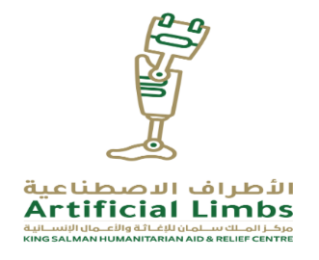

Figure 2.2 Artificial Limbs King Salman Center

Description:

Sensing the responsibility and importance of conducting humanitarian intervention to support those suffering from amputations, the King Salman Humanitarian Aid and Relief Center took the initiative to support and finance prosthetic limb centers, which provide their services free of charge to those suffering from amputations. The random mines planted by the Houthi militias caused havoc and destruction that extended to affecting and harming the lives and souls of innocent Yemeni citizens, through random and massive laying of mines, which killed and affected thousands of Yemenis and led to the occurrence of many cases of amputations and injuries, including many women and children in the Yemeni governorates.

Features:

-Provides a prosthetic limb fitting service for patients

-Training local cadres on prosthetic limb manufacturing techniques

- Rehabilitation of patients

-Supports English and Arabic

-Easy to use

Drawbacks:

-It does not have a standalone website or application

-The service is limited to a specific country

|  |  |  |  |
| --- | --- | --- | --- |
| Artificial limbs, King Salman Center | Prosthetic devices | Limb Revive | Feature |
| إغلاق مع تعبئة خالصة | إغلاق مع تعبئة خالصة | علامة تحديد مع تعبئة خالصة | Independent website |
| علامة تحديد مع تعبئة خالصة | علامة تحديد مع تعبئة خالصة | علامة تحديد مع تعبئة خالصة | Chat support |
| إغلاق مع تعبئة خالصة | إغلاق مع تعبئة خالصة | علامة تحديد مع تعبئة خالصة | Notification |
| إغلاق مع تعبئة خالصة | علامة تحديد مع تعبئة خالصة | علامة تحديد مع تعبئة خالصة | Discussion board |
| علامة تحديد مع تعبئة خالصة | علامة تحديد مع تعبئة خالصة | علامة تحديد مع تعبئة خالصة | Feedback |
| إغلاق مع تعبئة خالصة | إغلاق مع تعبئة خالصة | علامة تحديد مع تعبئة خالصة | Exercises & care |
| علامة تحديد مع تعبئة خالصة | إغلاق مع تعبئة خالصة | علامة تحديد مع تعبئة خالصة | Conferences |

Table 2.1 Related Words

**3. Methodology**

3.1 Introduction

In this chapter, we will present the functional and non-functional requirements for our site, and we will display diagrams to facilitate understanding of the site and clarify the method and mechanism of the site’s work, including: Use Case, Activity Diagram and Sequence Diagram.

3.2 Functional and Non-Functional Requirements

|  |  |
| --- | --- |
| Non-Functional | Functional |
| Performance | User Registration and Login |
| Security | Notification and Messaging |
| Reliability | User Support and Help |
| Accessibility | Appointment Reminders |
| Scalability | Feedback |
| Usability | Events and Conferences |

Table 3.1 Functional and Non-Functional Requirements

3.3 Use Case

Admin Use Case

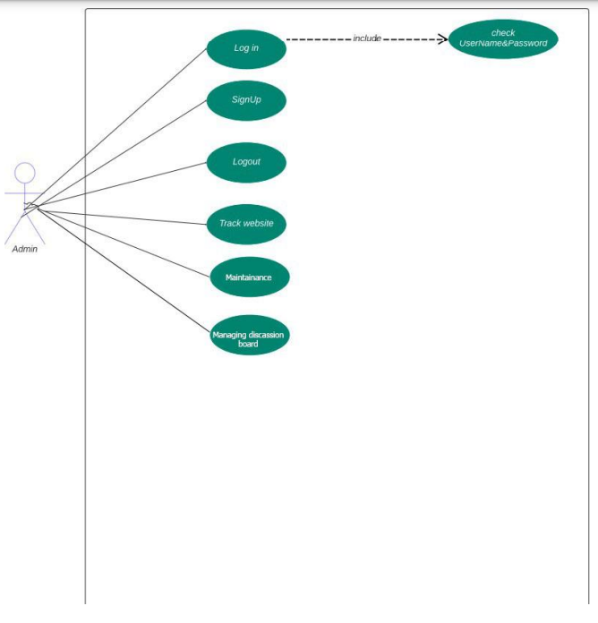

Figure 3.1 Admin Use Case

Hospital Use Case

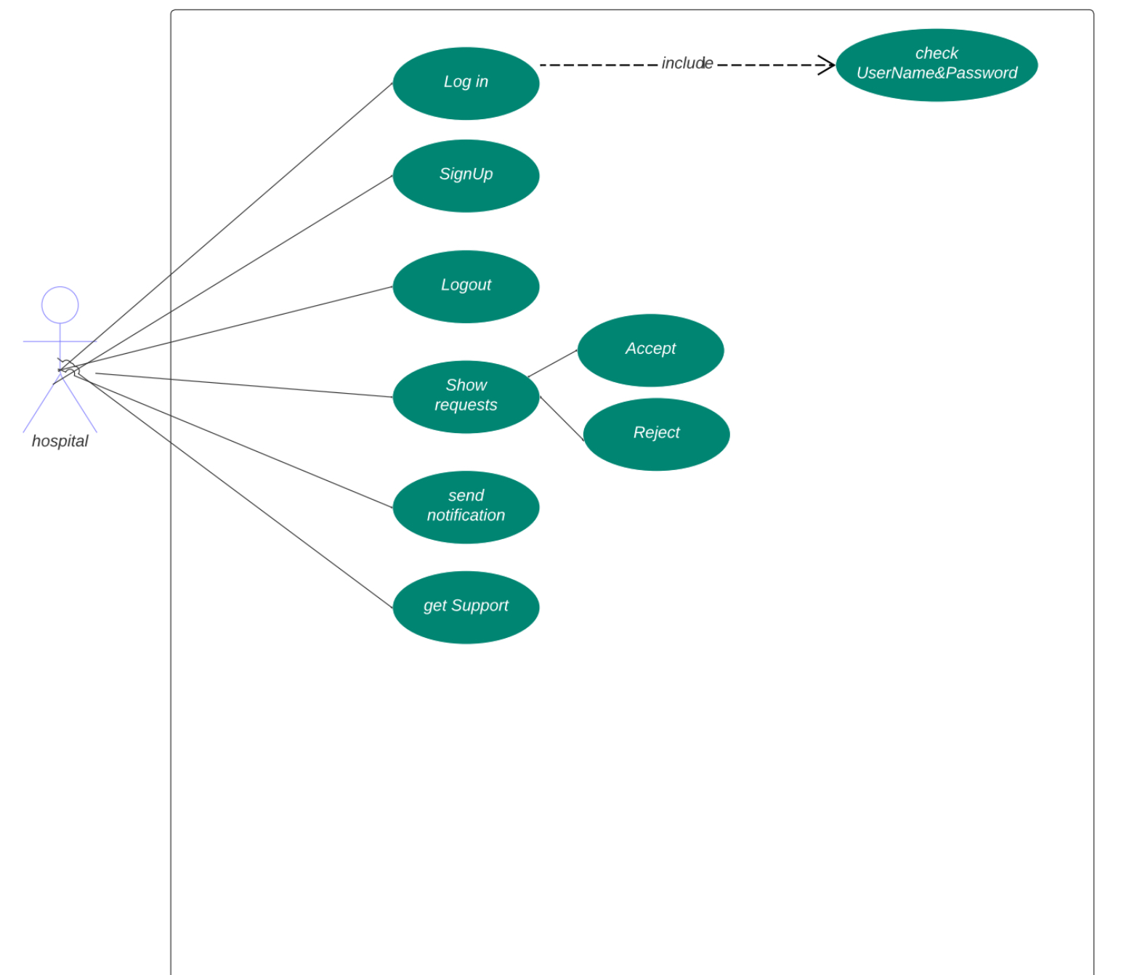

Figure 3.2 Hospital Use Case

User Use Case

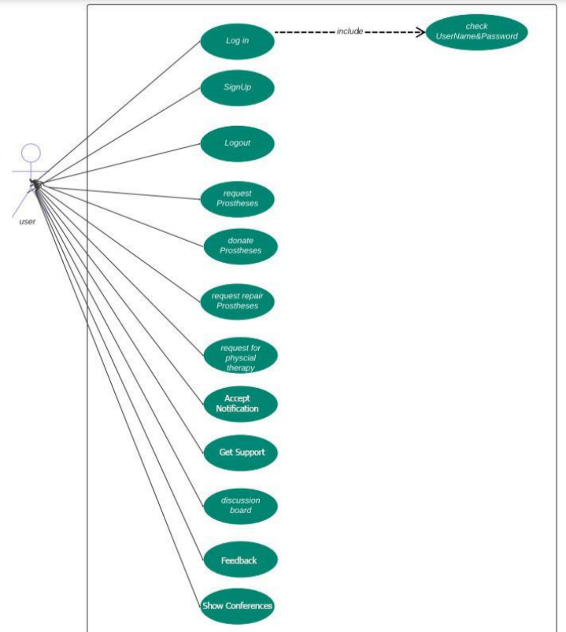

Figure 3.3 User Use Case

Donator Use Case

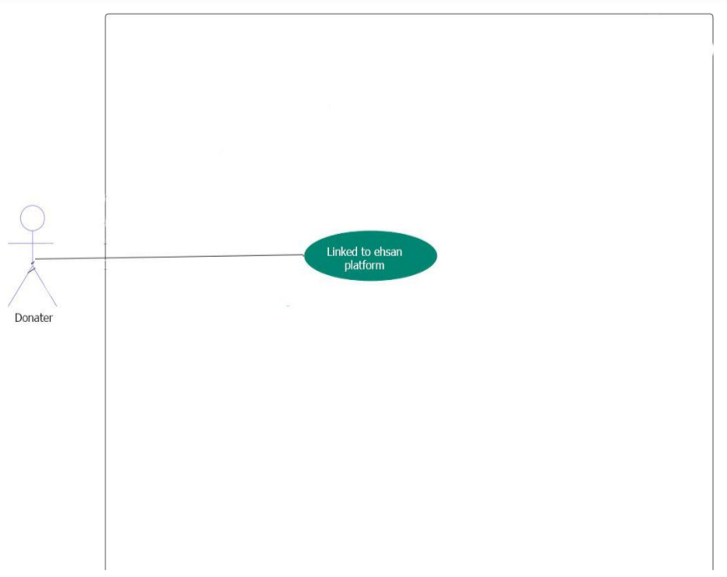

Figure 3.4 Donator Use Case

3.4 Activity Diagram

Admin Activity Diagram

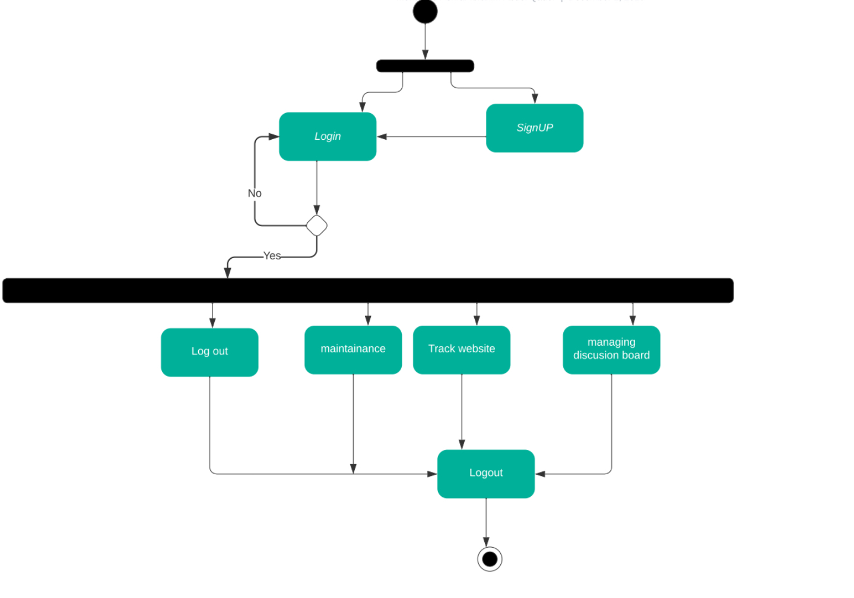

Figure 3.5 Admin Activity Diagram

Hospital Activity Diagram

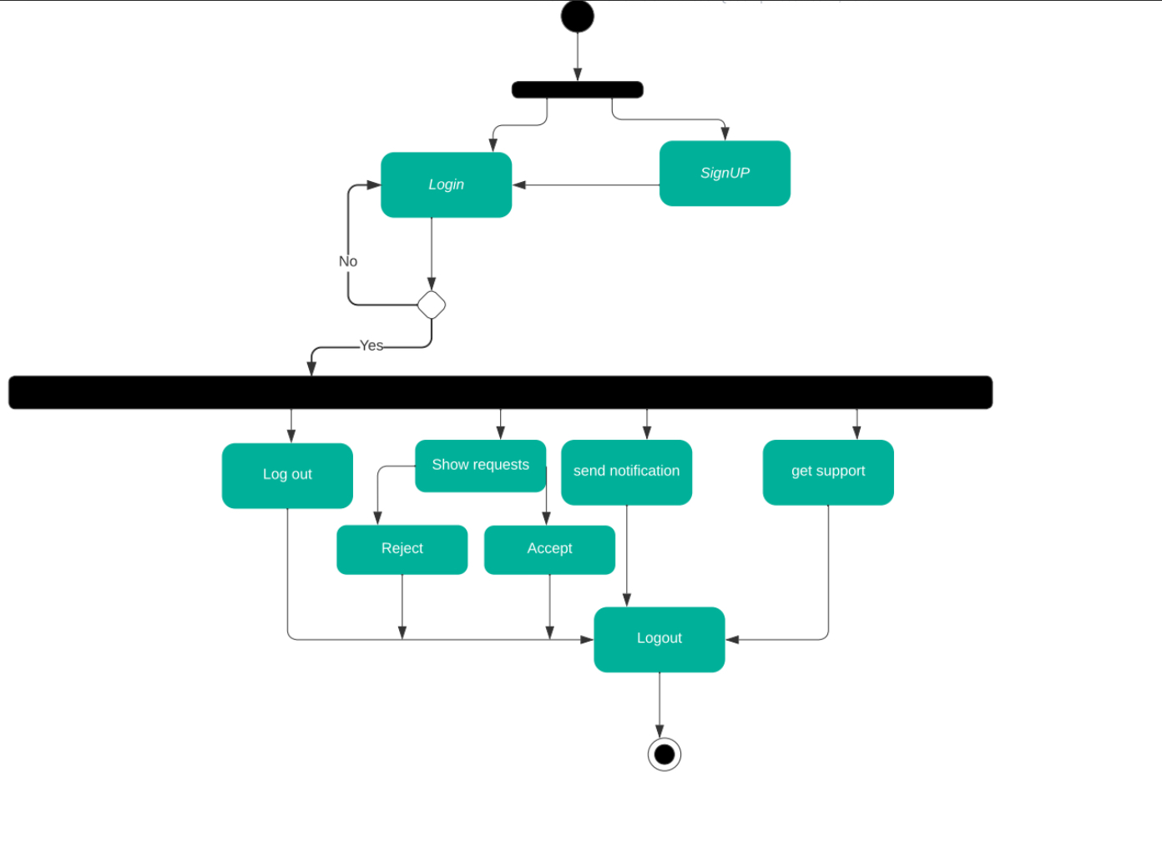

Figure 3.6 Hospital Activity Diagram

User Activity Diagram

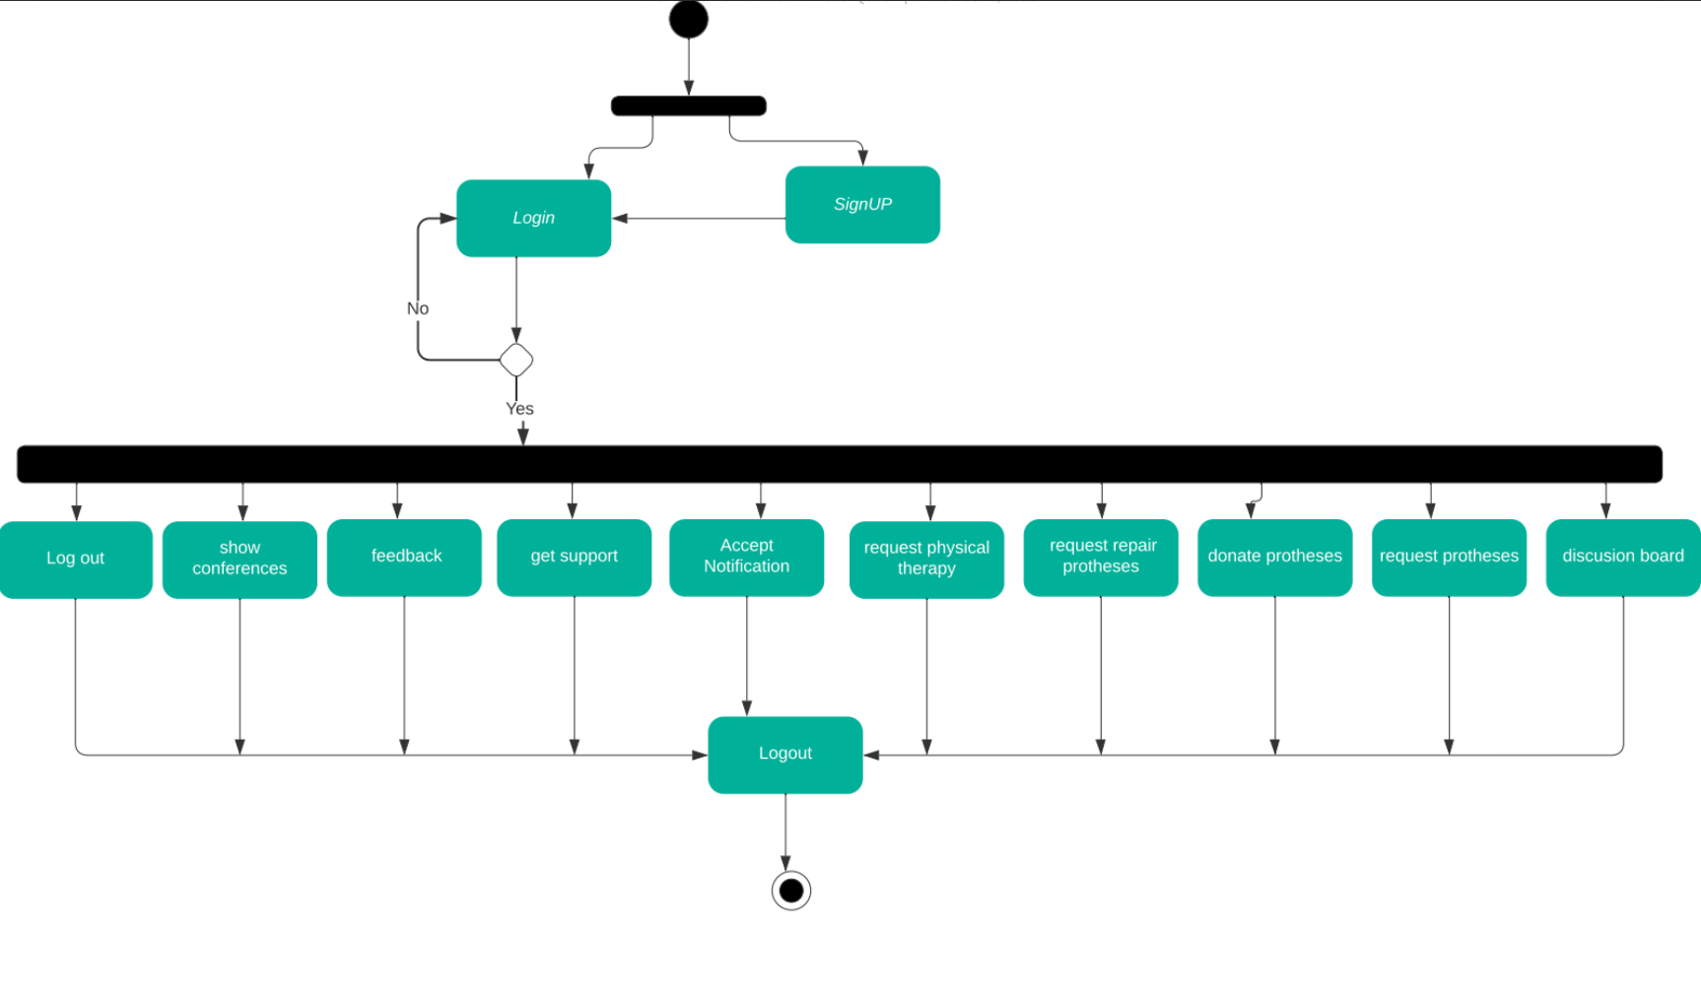

Figure 3.7 User Activity Diagram

Donator Activity Diagram

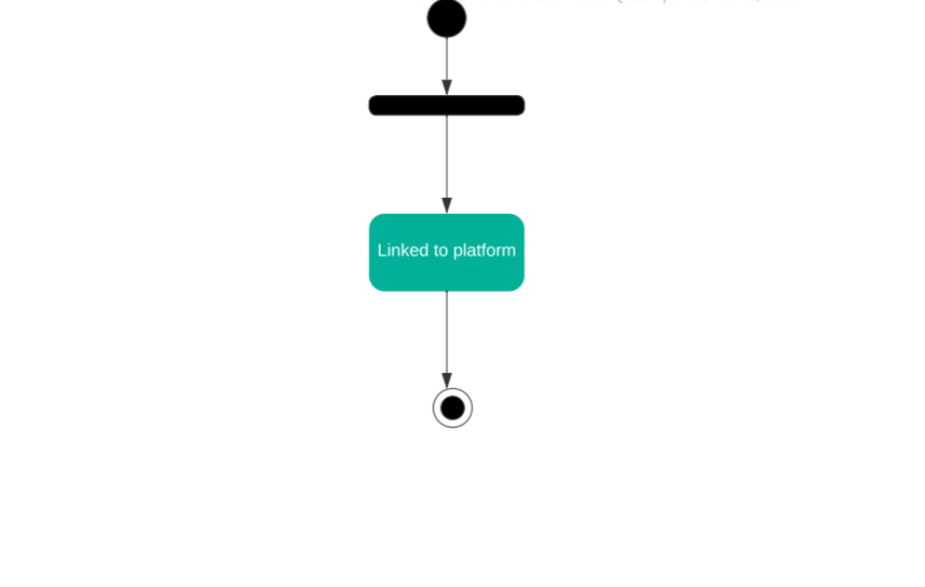

Figure 3.8 Donator Activity Diagram

3.5 Sequence Diagram

Sequence Diagram

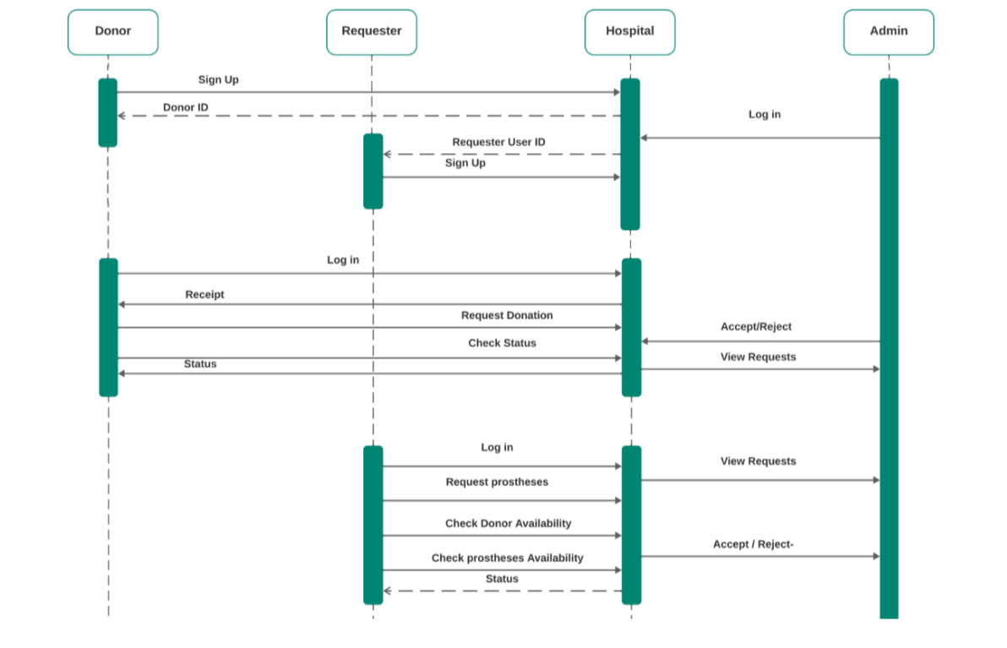

Figure 3.9 Sequence Diagram

3.6 ER Diagram

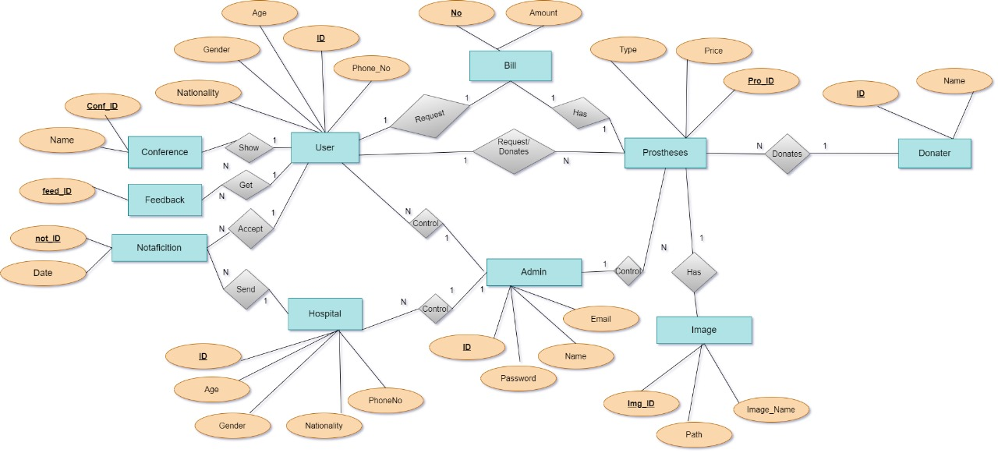

Figure 3.10 ER Diagram

3.7 Class Diagram

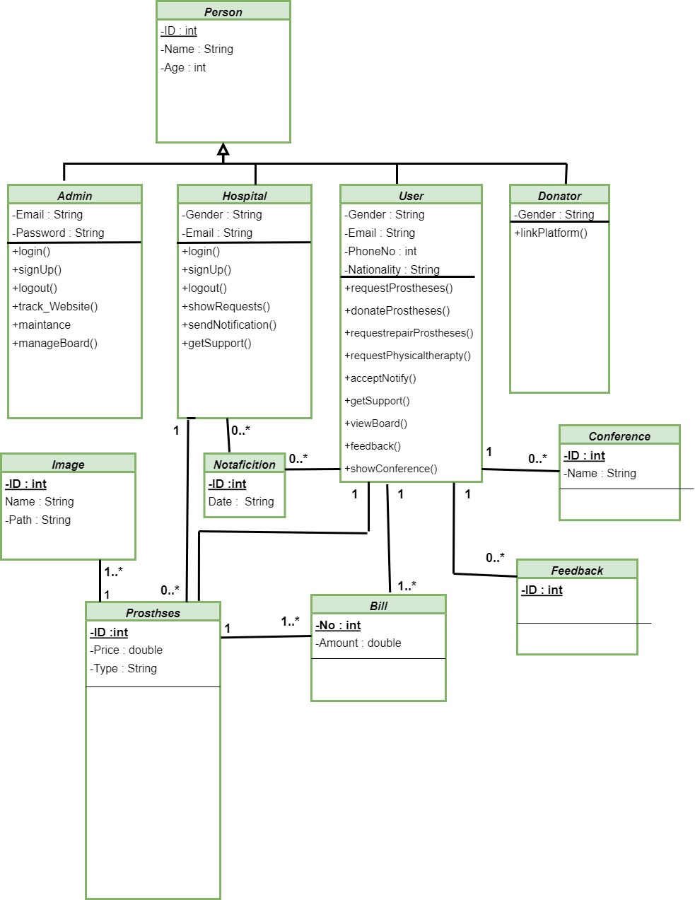

Figure 3.11 Class Diagram

**4. Implementation**

4.1 Introduction

In this chapter, we will mention the program requirements and present a layout of the program using

a sketch design for the website.

4.2 Program Requirement

1.Introduction

Overview of Limb Revive's purpose and goals Target audience and user

2. Background And Related Words

Detailed description of the website's functionalities

Features to be included (e.g., user registration, limb-related information, community ,donation portal, etc.)

3. Functional Requirements

User Registration and Login

Appointment Reminders

Notification and Messaging

Feedback

User Support and Help

Events and Conferences

4. Non-functional Requirements

Performance

Security

Scalability

Accessibility

Usability

Reliability

5. Implementation

Intuitive and user-friendly interface design

Branding:

Consistent branding elements (color schemes, logos, etc

Responsiveness:

Ensure the website is responsive and adaptable to various screen sizes.

4.3 Output Layout

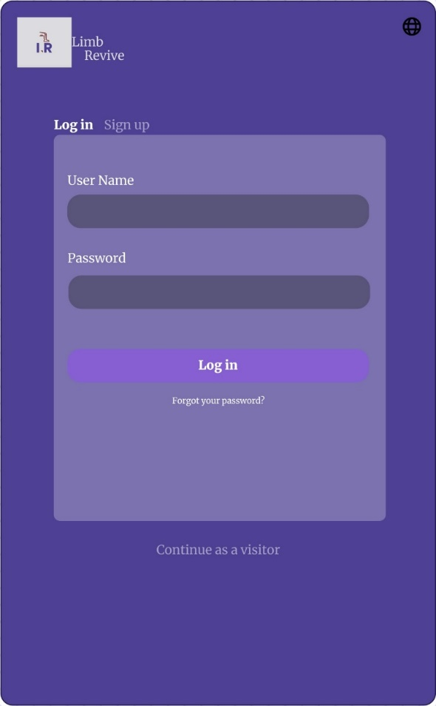

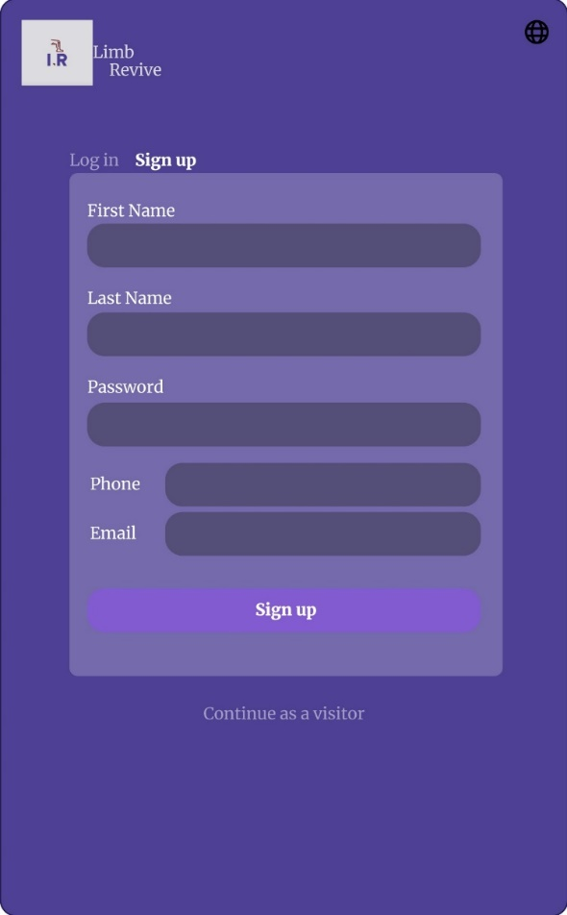

Figure 4.1 Log In

The user who has previously registered on the site enters the data and then logs in

Figure 4.2 Sign Up

For a new user who has not previously created an account, he enters the data and then sign up

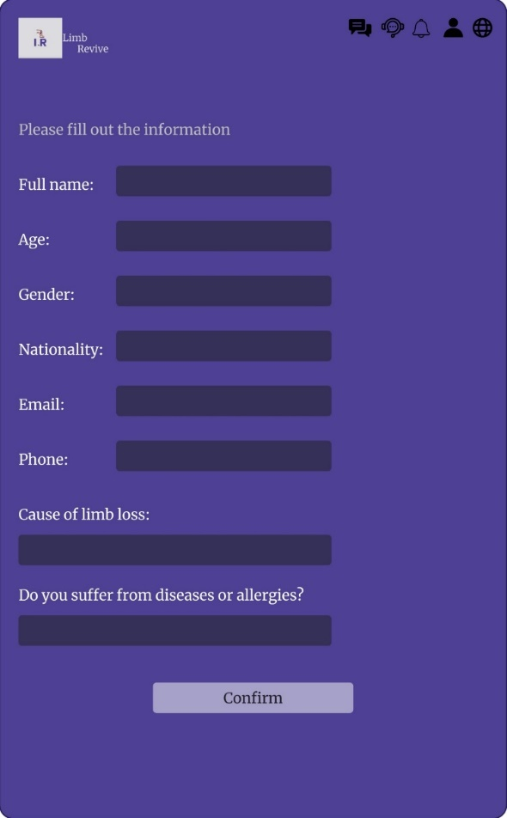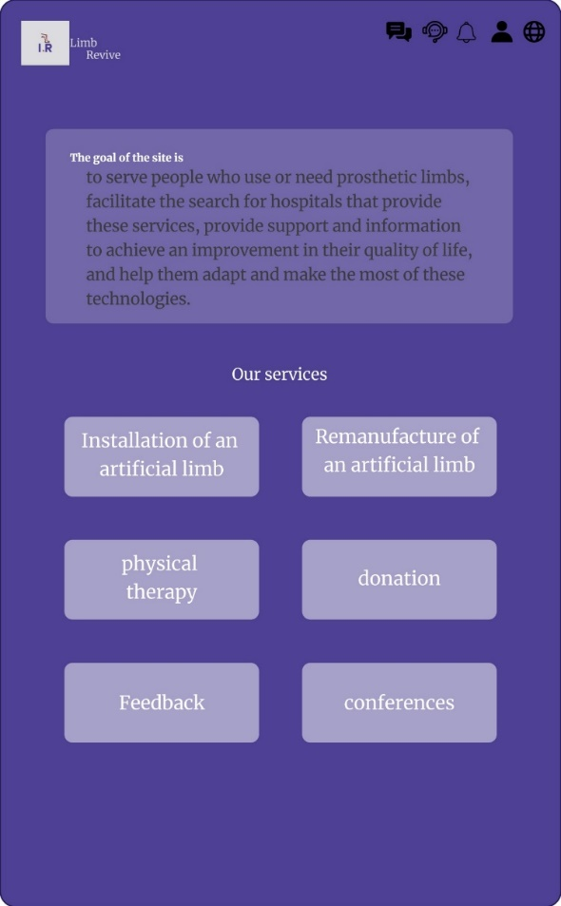

Figure 4.3 Home Page

The home page that contains all the services provided by our website

Figure 4.4 Installation

When clicking on the installation service, the patient fills in the data

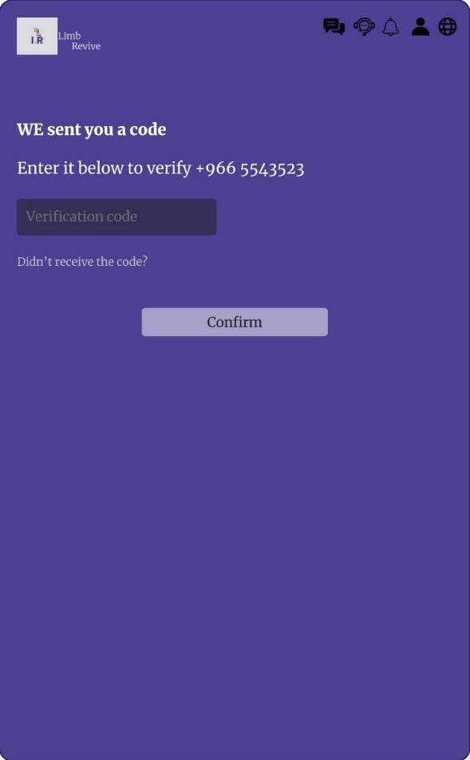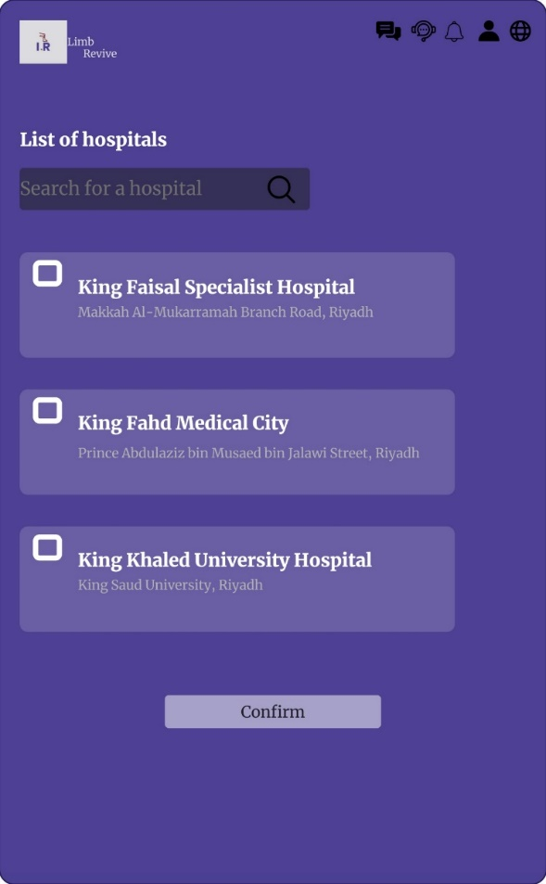

Figure 4.5 Installation

Figure 4.6 Installation

After filling out the data, the patient chooses the hospital

After selecting the hospital, a verification code is sent to the patient to verify the accuracy of the information entered

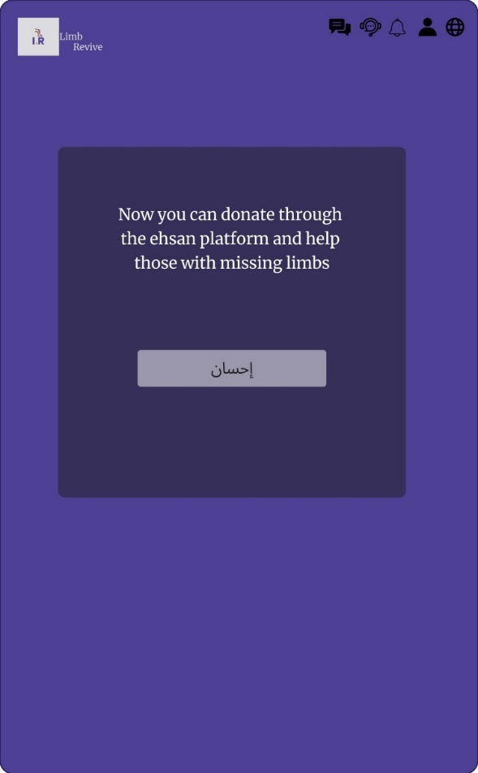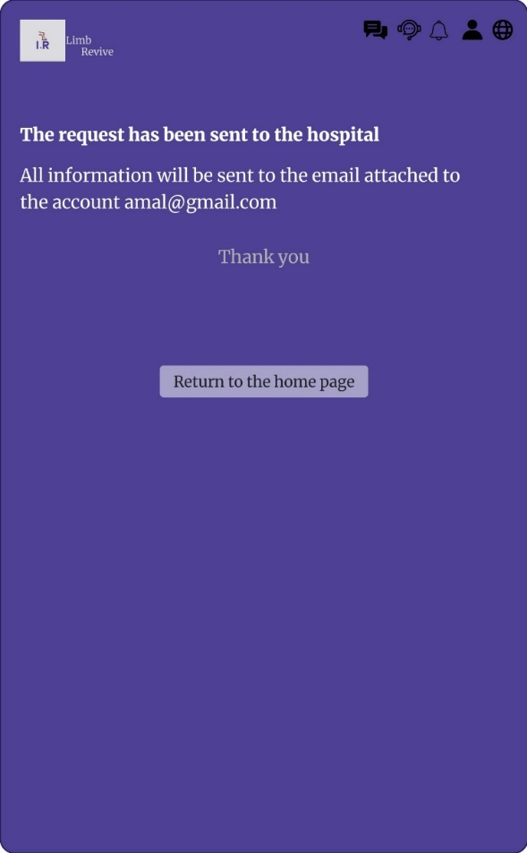

Figure 4.7 Installation

Figure 4.8 Donation

The request is then sent to the hospital and all information is sent to the patient via email

When you click on the donation service, the donor will be transferred to donate via the Ihsan platform

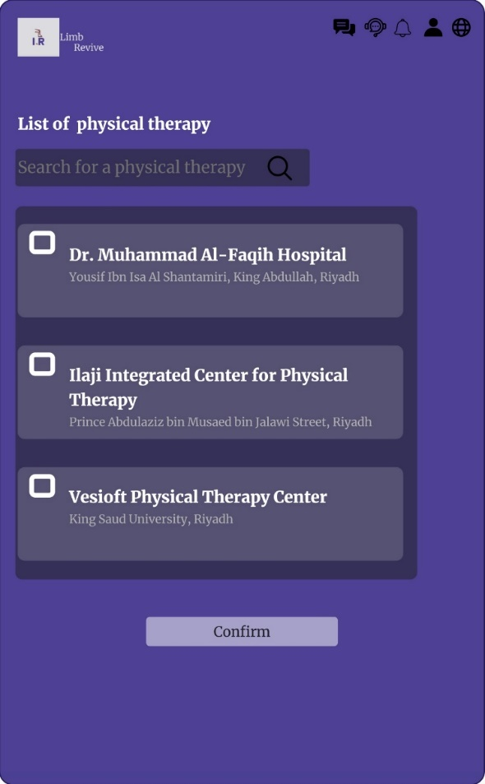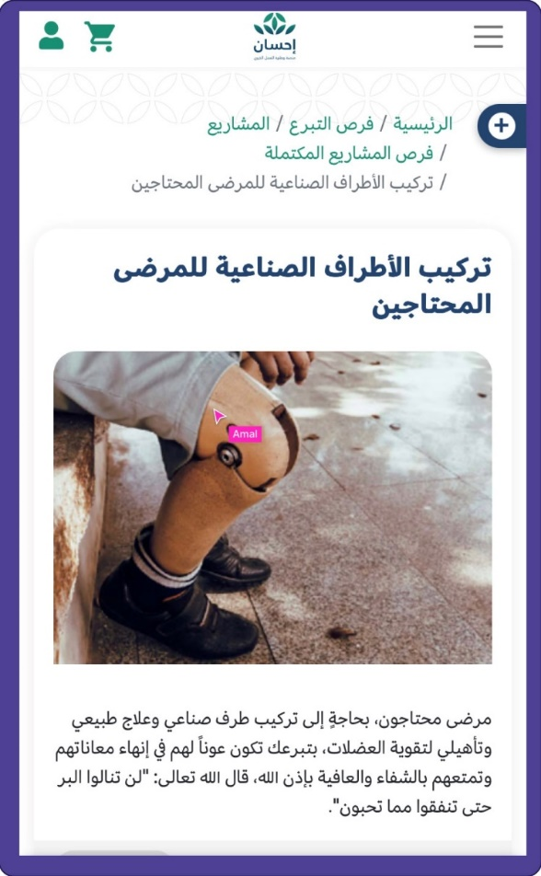

Figure 4.9 Donation

Figure 4.10 Physical Therapy

When you click on the donation service, the donor will be transferred to donate via the Ihsan platform

When you click on the natural lock service, a list of centers appears and one of them is selected

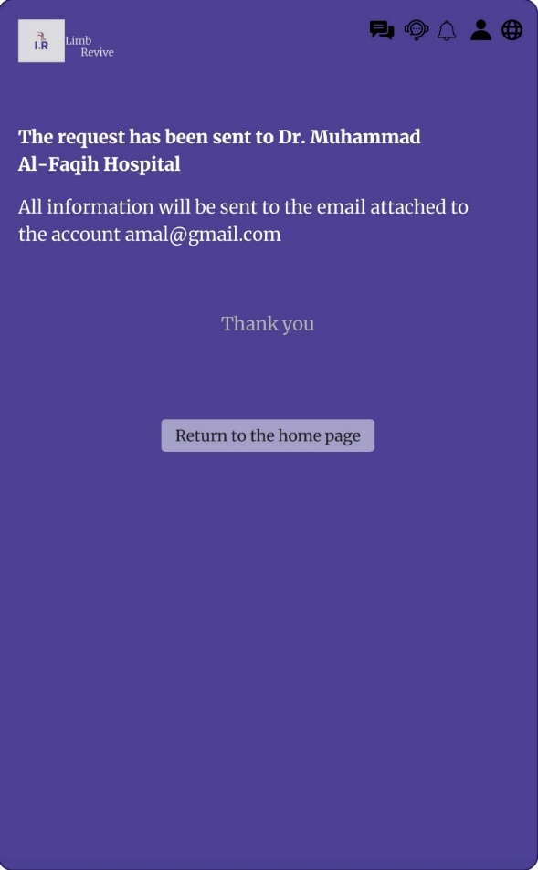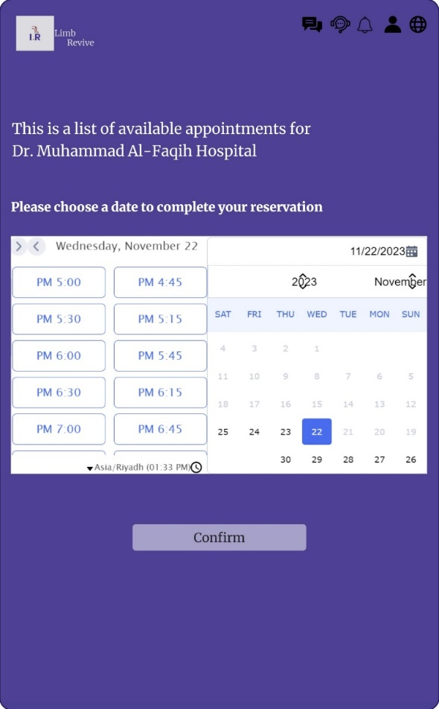

Figure 4.11 Physical Therapy

Figure 4.12 Physical Therapy

After choosing the center, the patient chooses the available day and time

After that, all information will be sent via email to the patient

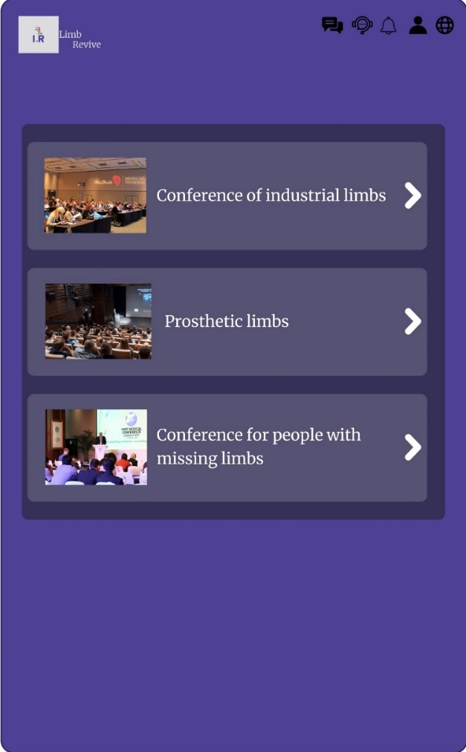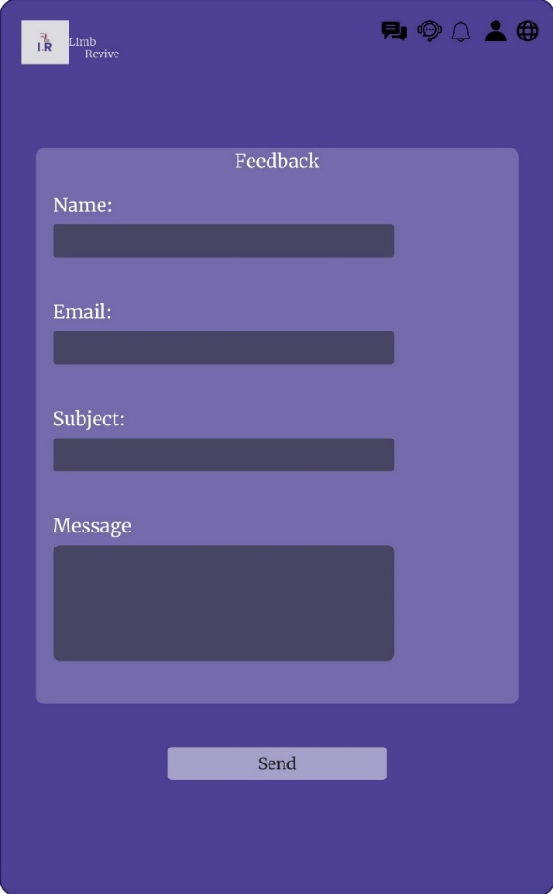

Figure 4.13 Feedback

It is a service that allows the patient to share his experience

Figure 4.14 Conferences

It is a service that allows the patient to attend events and conferences for people with missing limbs

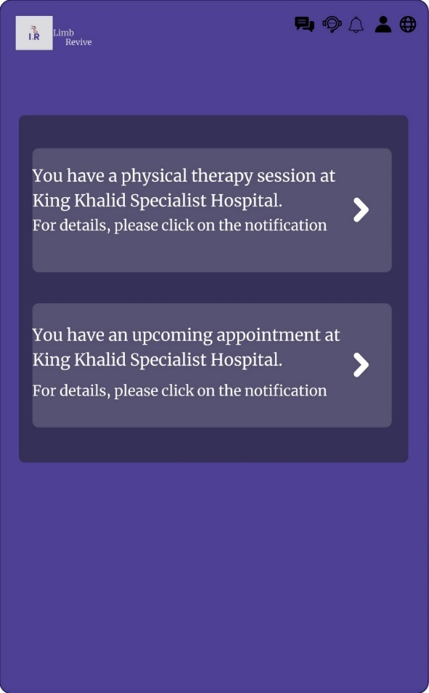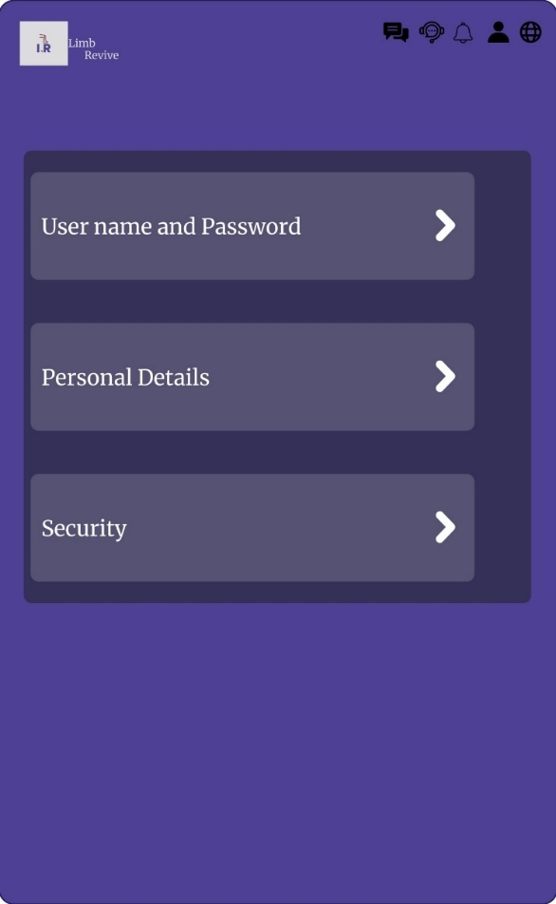

Figure 4.15 Profile

Account management settings

Figure 4.16 Notifications

User notification center

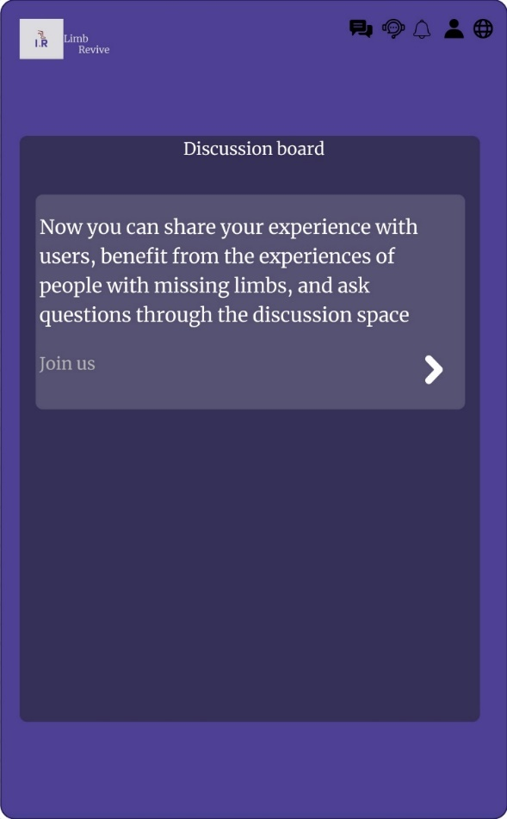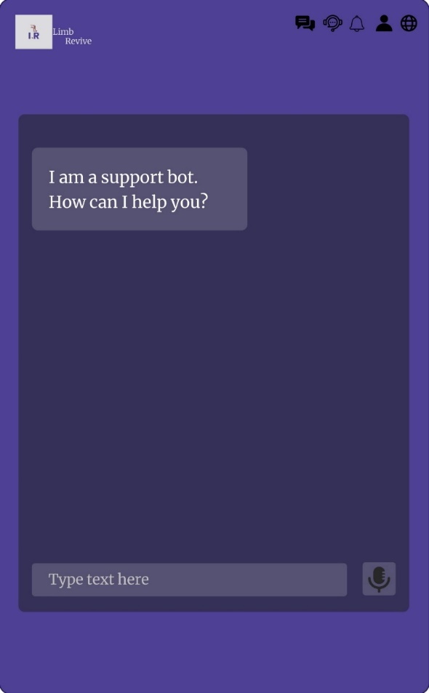

Figure 4.17 Chat Support

Chat support to help the user if any problem occurs

Figure 4.18 Discussion Board

It facilitates the communication process between users to benefit from experiences and solve problems

5. Conclusion and Recommendations

5.1 Conclusion

Based on the words of our master Muhammad, peace be upon him:

(مثل المسلمين في توادهم وتراحمهم وتعاطفهم كمثل الجسد اذا اشتكى منه عضو تداعى له سائر الجسد بالسهر والحمى)

We were inspired by the idea of ​​our website by embodying our experience in this technical field and our support for them and providing the necessary services to help them overcome the circumstances and difficulties they face in living their lives normally, such as immobilization and lactation to solve these problems. Our website exists to provide them with physical therapy, install artificial limbs, and support them. Morally by presenting daily messages: In Concussion, we thank the Kingdom’s family for the efforts made in providing the opportunity to teach technical specializations and the efforts of the students in devoting their education to serving the nation and Muslims. Special thanks to every doctor who supervised our education.

5.2 Recommendations



**5.3 Resources and References**

1. Prosthetic devices

<https://www.my.gov.sa/wps/portal/snp/servicesDirectory/servicedetails/8588>

2. Artificial Limbs King Salman Center

<https://www.ksrelief.org/Programs/ArtificialLimbs>